**Documentation for the Test scenarios using Selenium**

Created two different test cases for each story. Please find the detailed information below.

**Included Files:**

1. TestADP.Zip
2. UserStory1_index.html – User story 1 test results
3. UserStory2_index.html – User story 2 test results

User Story 1:

1. JanuaryNewReleaseBlurbDisplayTest Method

This will get the collection of Descriptions from the January month, iterate over the collection to identify the description exists for each of the shoe item in January Release.

Note: I have used different method to test each month with the common functionality getting month name as input to avoid duplicate code implementation.

1. JanuaryNewReleaseSuggestedPriceTest Method

For each item, I had passed price value with the Name information, to identify the price against the Name to validate. This also takes input as Month.

Note: Each month will replicates the same logic with the common functionality in addition to that getting month name as input to avoid duplicate code implementation.

1. JanuaryNewReleasePriceTest Method

This will get the collection of price information from the January month, iterate over the collection to identify the price value exists for each of the shoe item in January Release.

Note: I have used different method to test each month with the common functionality getting month name as input to avoid duplicate code implementation.

1. JanuaryNewReleaseImageDisplayTest Method

This will get the collection of image information from the January month, iterate over the collection to identify the image source value exists for each of the shoe item in January Release.

Note: I have used different method to test each month with the common functionality getting month name as input to avoid duplicate code implementation.

User Story 2:

1. ReminderEmailTest Method

This method helps to test the reminder of new release email submission functionality. Passing test email id for submission. When I do enter on submit of reminder email, it shows the successful entry of message display.

**Additional Information related to the test script code implementation.**

I have created separate methods for each month to validate Description display, Image display, Price display and in addition to the Price input validation against each shoe item in a given month release.

Alternative ways to display:

Here simply I used **Thread** sleep, instead I can use wait and wait until functionality.

I would also use **NewReleaseShoe** Class to pass values for each shoe item for verification.

Softwares Used:

Java, Eclipse, TestNG, Selecnium for Java language and also Chrome driver.

Selenium 3.0.0

Please find the sample screen shot for the script run.

User Story 1:

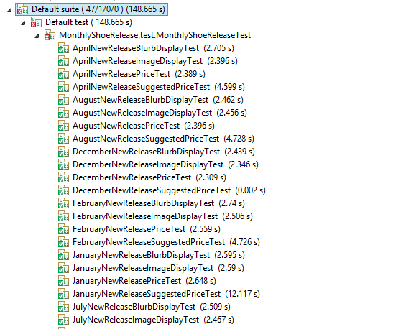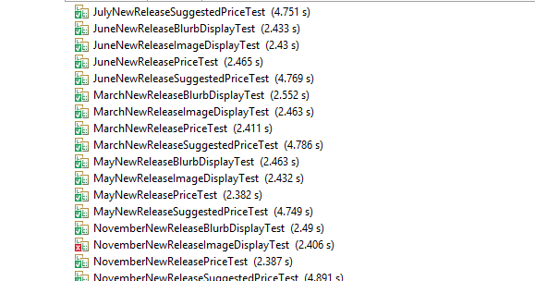

User Story 2:

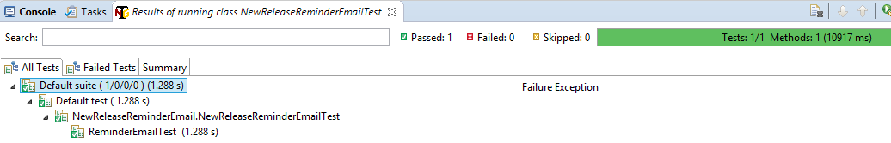

Project structure IDE

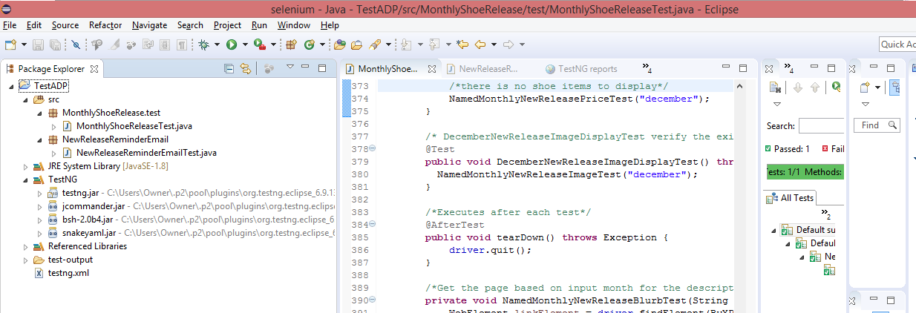

I have given my local path for chromedriver.exe

